# **Blackboard Content Editor – Inserting an Image**

**March 2, 2021**

A Blackboard update on Feb 25, 2021 included an unexpected change to the Content Editor. Users are no longer able to Cut and Paste images from a local drive or other sources. Instead, users must utilize the Add Content feature in the Editor to insert an image.

**To do that, navigate to the location where you want to add content and open the Edit functionality using the dropdown caret.**

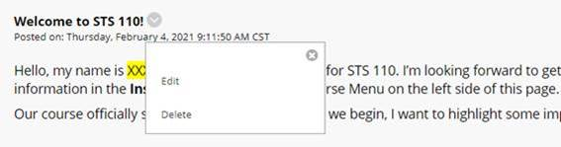

**In the Editor, find the Add Content button and click on it.**

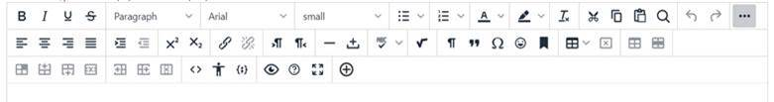

**Once the Add Content menu opens, click on the Insert Local Files option and navigate to the location where your image is currently stored.**

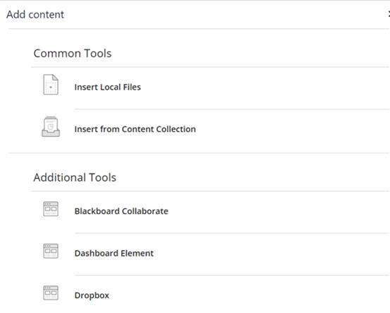

**Select the image file you want to add and click Open to complete the process.**

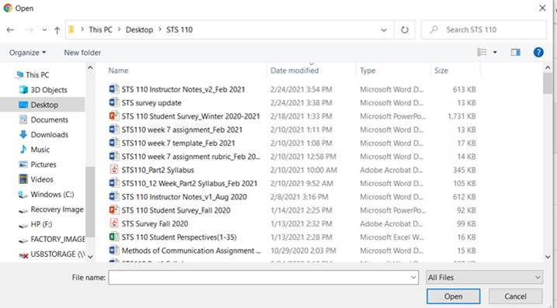

Please let us know if you have any questions or encounter any issues.